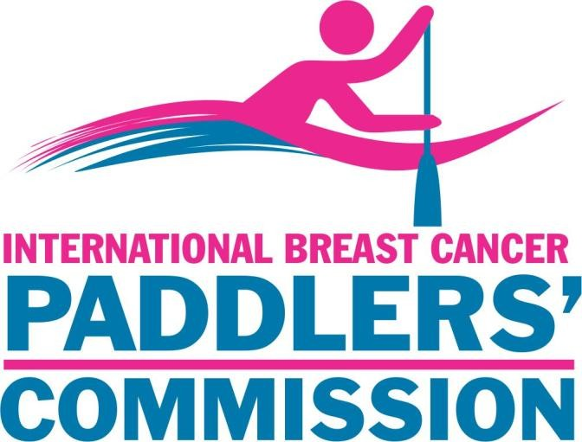

International Breast Cancer Paddlers’ Commission (IBCPC) www.ibcpc.com

The International Breast Cancer Paddlers’ Commission (IBCPC) is an organisation grounded in compassion, community, and the shared belief that life after a breast cancer diagnosis can be powerful, connected, and full of possibility. Our mission is to encourage, support, and unite breast cancer dragon boat teams across the world. As of March 2026, there are 403 teams from 42 countries paddling together in strength and solidarity.

IBCPC Representative Program

The IBCPC Board of Directors, representing countries across the globe, works alongside dedicated National Representatives (NRs) and Country Liaisons (CLs) who serve as the heart of our communication and connection with local teams. These roles ensure that every paddler, no matter their team or location, feels included, supported, and linked to the wider international community.

When a new country joins the IBCPC, a Country Liaison is appointed to collaborate with the Regional Coordinator until the country has at least three teams, at which point a National Representative may be appointed. Current NRs with fewer than three teams will continue in their roles.

NRs and CLs serve as vital bridges between the IBCPC and the member teams, fostering shared knowledge, celebrating achievements, and strengthening the bonds that unite our community.

Role of the National Representative (NR) / Country Liaison (CL)

Promotion
- Be a warm and welcoming point of contact for teams in your region on matters relating to the IBCPC and breast cancer dragon boating.
- Champion the vision and values of the IBCPC, as outlined in the Our Mission section of the website.
- Provide guidance, support, and encouragement to new and developing teams, including helping them access IBCPC resources.
- Promote IBCPC membership and keep both the Membership Director (membership@ibcpc.com) and your Regional Coordinator informed about new or developing teams.

Engagement
- Create safe, supportive spaces—through video calls, leadership groups, or informal communication channels—where team leaders can share experiences, ideas, and questions.
- Hold regular meetings (suggested every two months) to help teams stay connected and involved.
- Share relevant medical and wellness resources from the IBCPC website, and forward local medical references to the Communications Director (comms@ibcpc.com) and Regional Coordinator.
- Support teams in raising medical, safety, or wellbeing concerns and ensure these are referred appropriately to the IBCPC Medical Advisory Panel.

Reporting
- Annually update your region’s team contact information through your Regional Coordinator.
- Submit quarterly updates outlining developments, successes, concerns, or news from your region.
- Send news items and stories from your region for the IBCPC newsletter (ibcpcnewsletter@gmail.com).
- Share details about local dragon boat events—festivals, clinics, seminars—to help promote them on the IBCPC website.
- Attend at least one annual regional meeting with your Regional Coordinator and any available Board Directors.
- Support distribution of the annual information survey to your teams.

Team Development
- Provide a member team guide to teams in your country.
- Encourage paddlers and teams to stay informed through the IBCPC website, newsletter, Festival bulletins, and social media.
- Assist with IBCPC Congress activities during Festivals when possible (travel and accommodation are at personal cost).

Revised February 2026

